Student Registration Form
1. Project Overview & Implementation Details
This student registration form collects and validates essential applicant details such as student ID, full name, email, phone number, and birth date before submission. To validate the information, custom JavaScript regex patterns and checks are run against user inputs to ensure they meet the specific institutional formatting rules. We used preventDefault() on the form's submit event listener to stop the browser from performing a default page refresh so our custom client-side validation logic can run first. When invalid entries are detected, errors are dynamically displayed right beneath the respective input fields with clear, user-friendly feedback messages. We managed these visual states effectively by toggling CSS classes like 'error' and 'success' on the elements to apply appropriate borders and label coloring. Additionally, we leveraged data-* attributes and the dataset property in JavaScript to store custom validation messages and configuration rules directly on HTML elements. Specifically, we manipulated the className and textContent attributes dynamically to update error states, container classes, and feedback banners in real-time.
2. Form Walkthrough Screenshots
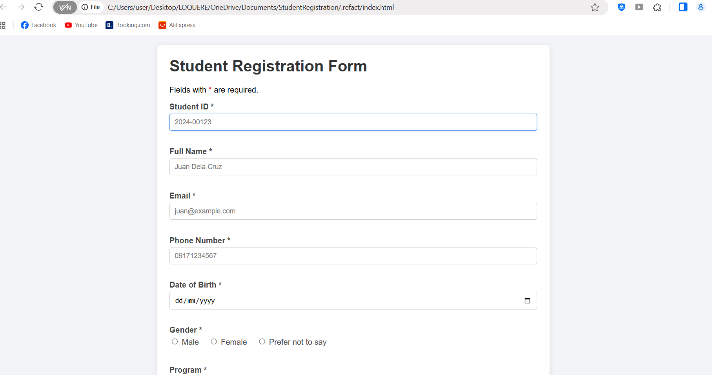
Figure 1: Initial Form – before entering information.
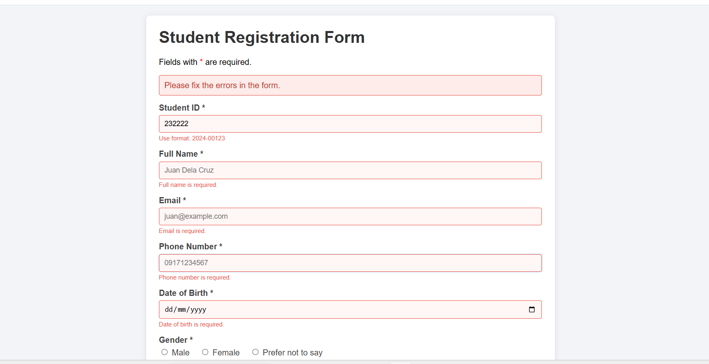
Figure 2: Validation Errors – showing incorrect or incomplete information.
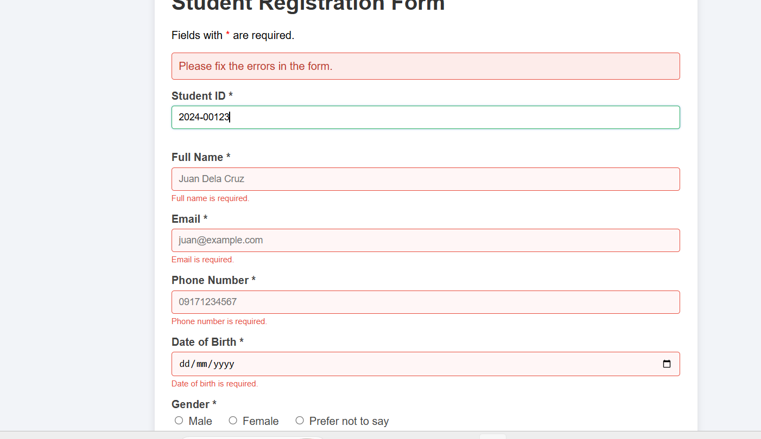
Figure 3: Corrected Form – showing errors being corrected.
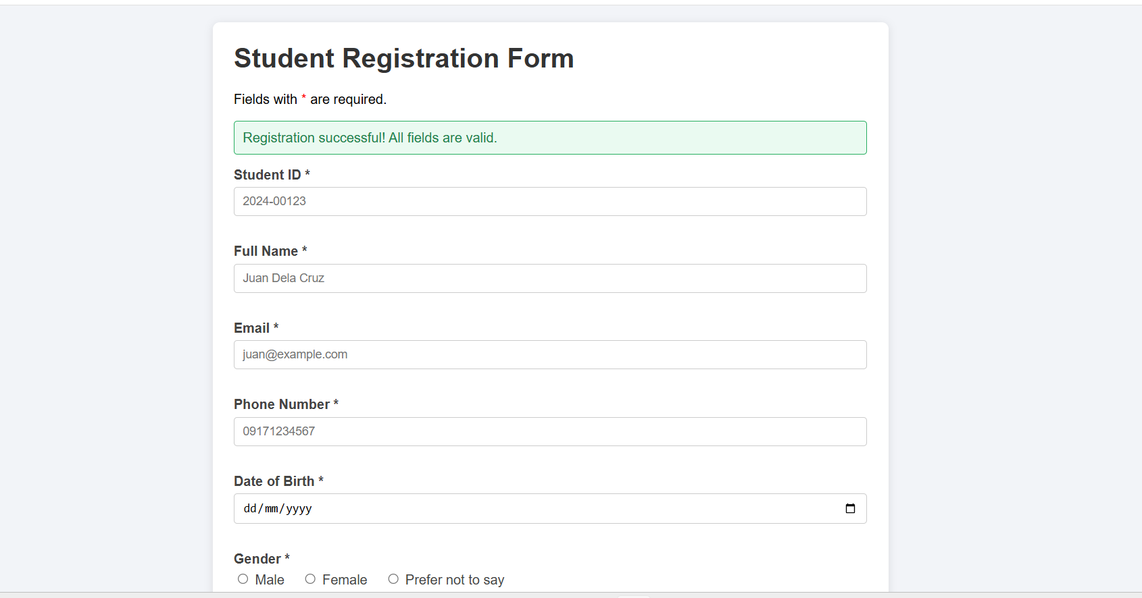
Figure 4: Successful Form – showing the success message.

